

Project title: EE Connection

Year: 2019

Project supervisor: Mohammed Chamseddine

Students: Jounaid Al-Saadi

Bassam Kaddoura

Contents

**Event Table** 2

**Decomposition Diagram** 4

**Context Diagram** 5

**Single Logical and Physical DFDs** 6

Register, Upload CV 6

Login 7

View Jobs, By Categories, Job Description 8

Apply 9

Feedback 10

Update Profile 11

Add Companies 12

Adds Jobs 13

Remove Jobs 14

View and Edit Members 15

Reply 16

## **Event Table**

|  |  |  |  |  |
| --- | --- | --- | --- | --- |
| **Actor** | **Use Case** | **Description** | **Actor Action** | **System Response** |
| Guest | Navigate | This use case allows all the actors to navigate the system, including information about the system, FAQs, and job listings. | The actor chooses pages to view. | The system directs the actor to the correct page. |
| Guest | Registration | This use case allows the actor to register to become a member through supplying his/her demographic information. | The actor enters all required information properly. | The system creates a new account in the member and person databases according to the information entered by the actor. |
| Guest | Upload CV | This use case lets the actor upload his CV as part of the registration process. | The actor uploads the CV file during the registration use case, or the “update profile” use case. | The system checks the validity of the file and attaches the file to the relative account. |
| Member | Login | This use case allows logs the actor into the system as an admin/member depending on the input information. | The actor chooses to login by entering his email and password. | The system checks the input information and accordingly grants access to the actor. |
| Member | View Jobs | This use case allows the actor to view available job offerings on the system. | The actor navigates to the job offerings section. | The system loads the content of the page by accessing the jobs database. |
| Member | By Categories | This use case allows the actor to view the listings in categories by filtering out the categories he is not interested in. | The actor chooses a specific category. | The system hides all jobs that don’t belong to the chosen category. |
| Member | Job Description | This use case provides a description about the job (Work hours, salary, location, etc…). | The actor requests the description of a specific job. | The system fetches the job description from the Jobs database. |
| Member | Apply | This use case allows the actor to apply to a job through automatically sending the CV to the employer. | The actor chooses to apply to a specific job. | The system confirms the validity of the application and forwards it to the employer. |

|  |  |  |  |  |
| --- | --- | --- | --- | --- |
| **Actor** | **Use Case** | **Description** | **Actor Action** | **System Response** |
| Member | Feedback | This use case gives the option for the actor to send feedback and suggestions to the developers of the page for further improvements. | The user accepts to give feedback to improve the system. | The system stores the feedback message and forwards it to the admins. |
| Member | Update Profile | This use case keeps the option of changing the updating the profile (including CV) available for members. | The use decides to update his/her profile. | The system contacts the person database and updates all relevant data. |
| Member | Contact | This use case allows logs the actor into the system as an admin/member depending on the email. | The actor chooses to contact the admins to inquire about some issues. | The system checks the validity of the message, stores it, and forwards it to the admins. |
| Admin | Login | This use case allows logs the actor into the system as an admin/member depending on the email. | The actor chooses to login by entering his email and password. | The system checks the input information and accordingly grants access to the actor. |
| Admin | Add Companies | This use case grants the ability for admins to add new job companies to the system. | The actor proceeds to enter a new company to the database. | The system checks the validity of all input information and accordingly update the Companies database. |
| Admin | Add Jobs | This use case grants the admins the ability to add new job offerings that arise. | The actor proceeds to enter a new job listing to the database. | The system checks the validity of all input information and accordingly update the jobs database. |
| Admin | Remove Jobs | This use case gives the admins the ability to remove listings when employers inform them that they have been filled. | The actor proceeds to remove a no-longer available job listing. | The system updates the jobs database. |
| Admin | View Members | This use case gives the admin access to view certain information about all members so that he/she can properly moderate the system. | The actor requests data about a specific member | The system loads the proper data from the members database and shows them to the admin. |
| Admin | Edit Members | This use case gives the admin permission to act on members’ accounts ( delete, ban, warn, edit), in order to keep the system under control. | The actor decides that a change in a member’s profile is needed, and proceeds with it. | The system updates the member database accordingly. |
| Admin | Reply | This use case allows for admins to message the members back regarding issues they are facing or questions they are having about the system. | The actor chooses to reply to a specific message from a member, | The system stores the message in the database and forwards the reply to the members. |

## **Decomposition Diagram**

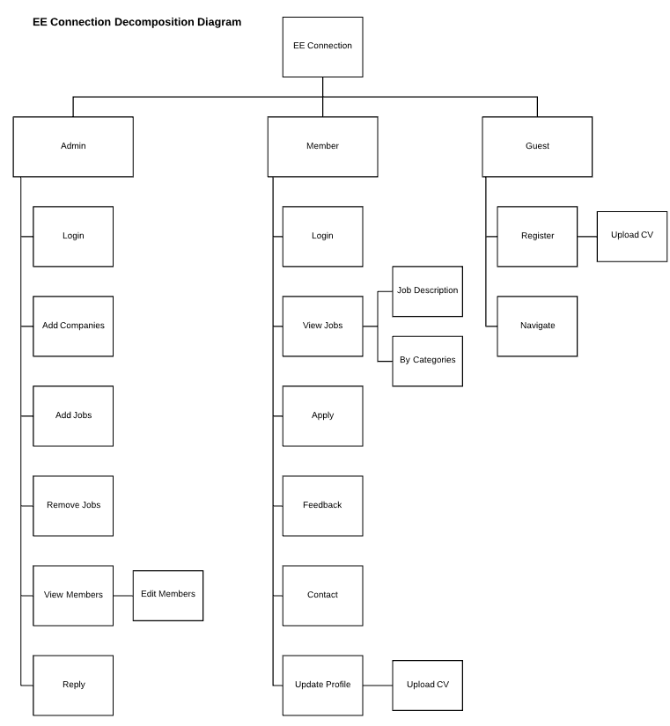

## **Context Diagram**

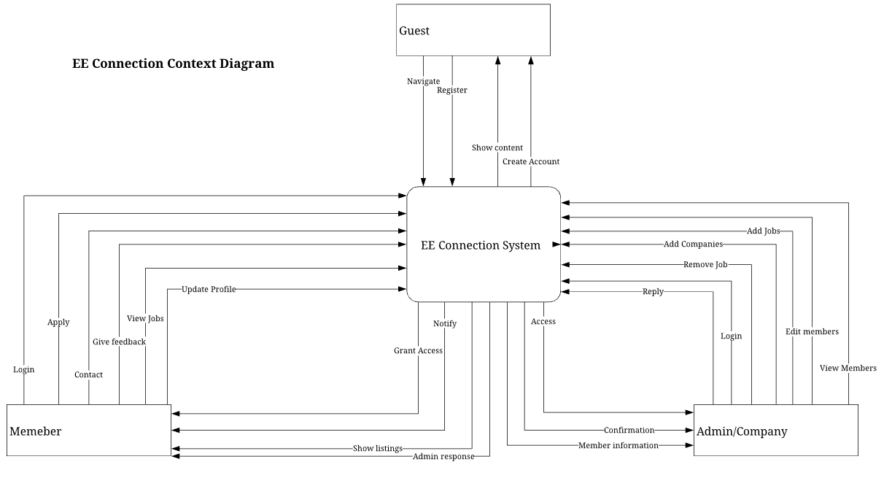

## **Single Logical and Physical DFDs**

### Register, Upload CV

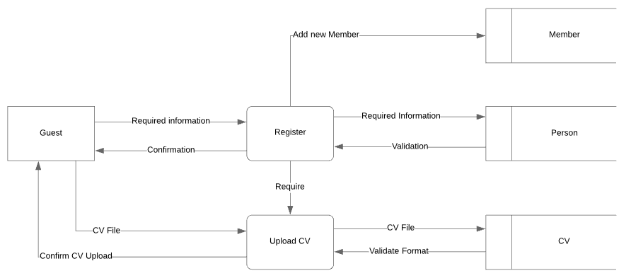

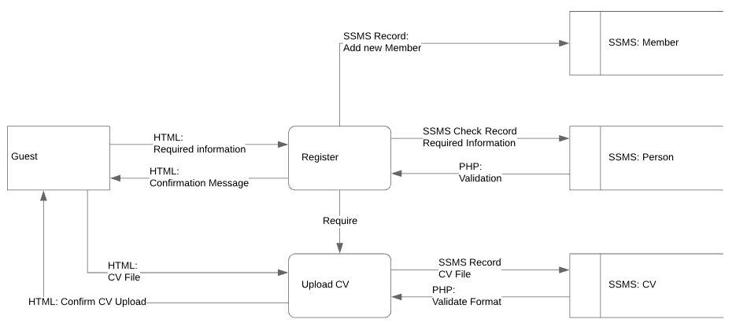

### Login

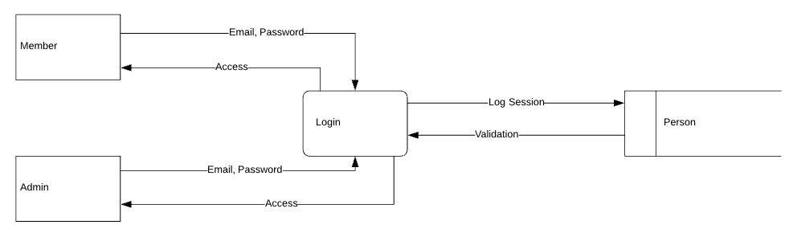

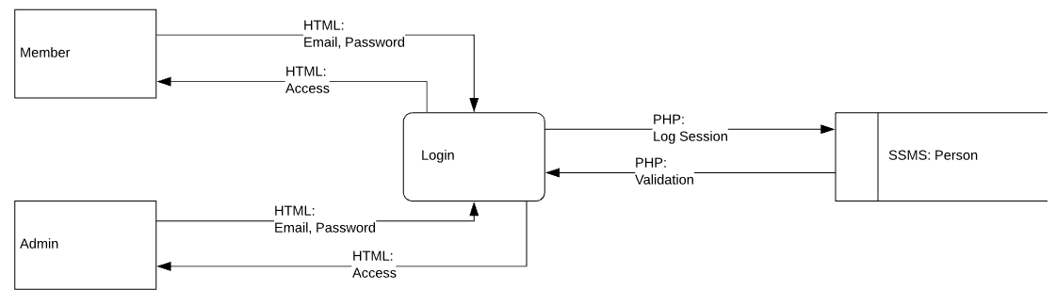

### View Jobs, By Categories, Job Description

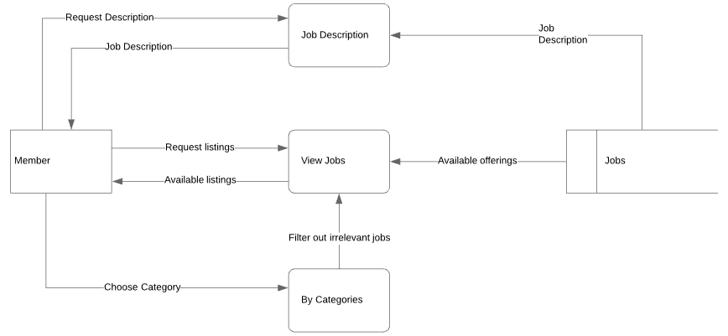

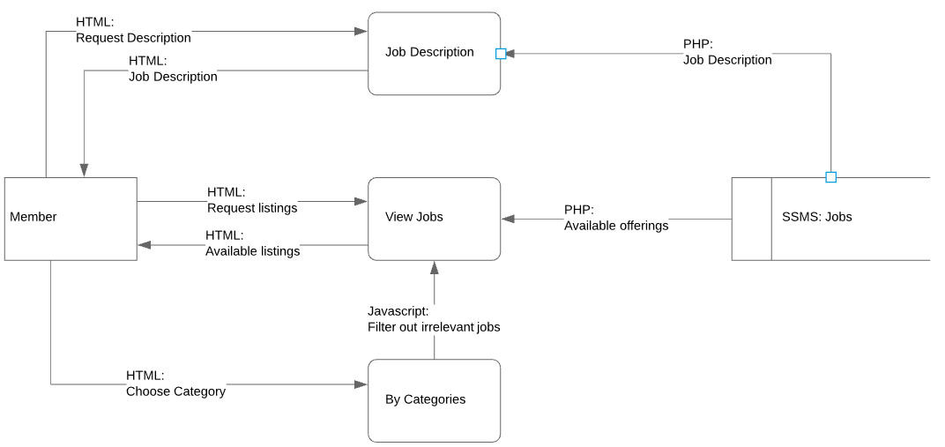

### Apply

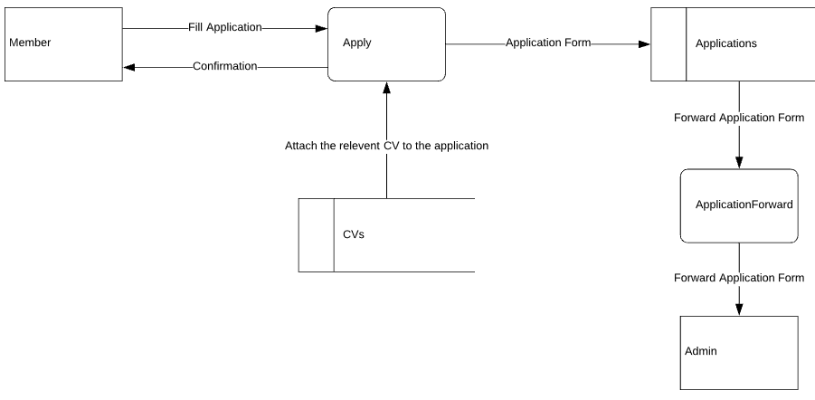

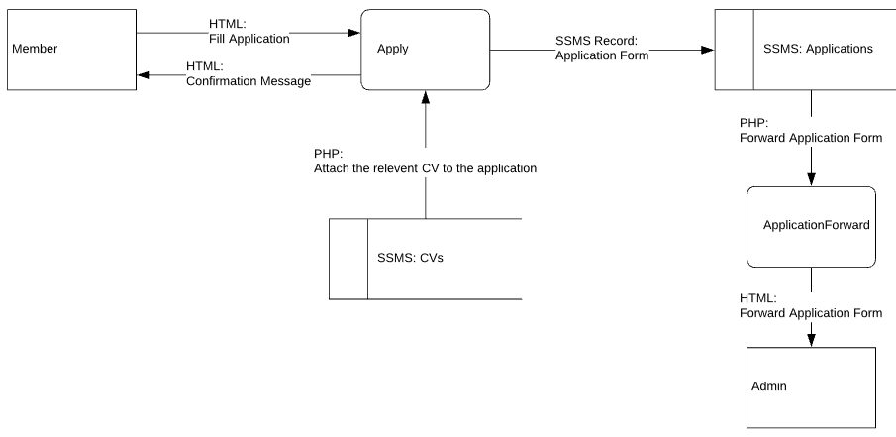

### Feedback

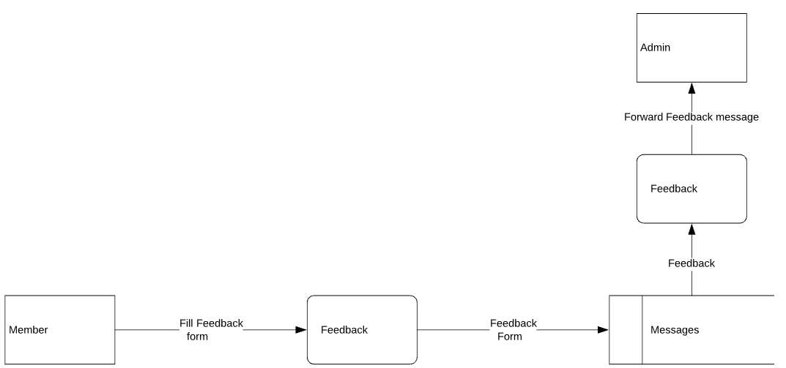

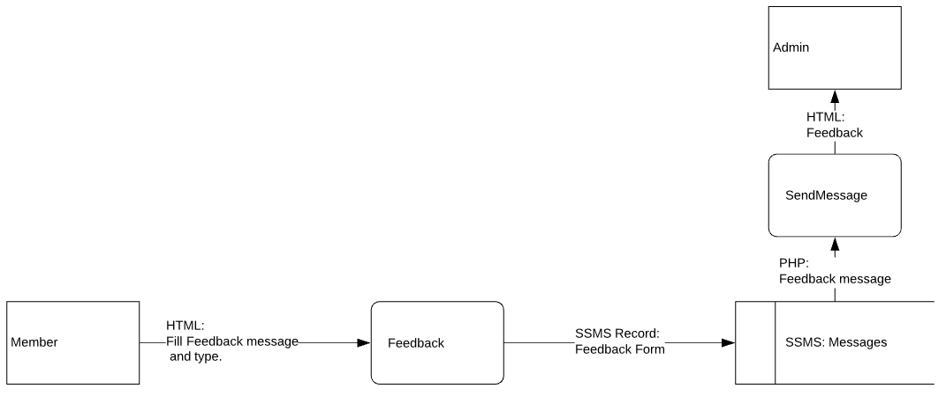

### Update Profile

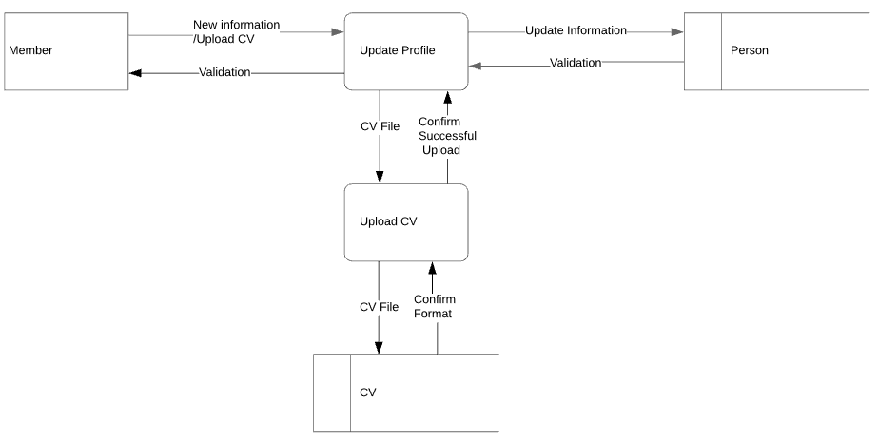

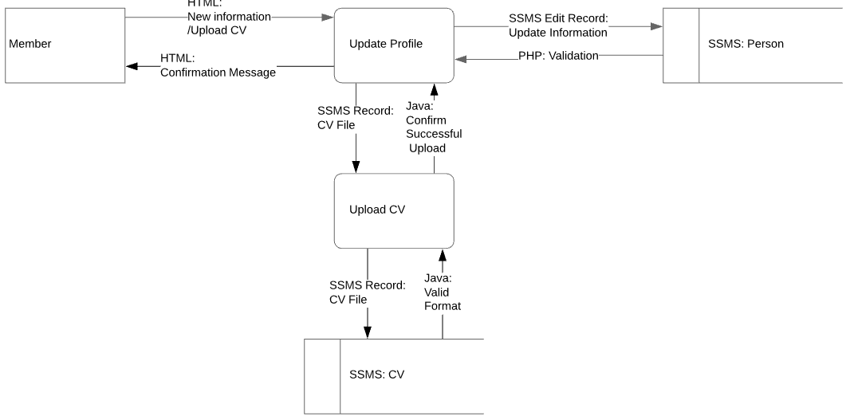

### Add Companies

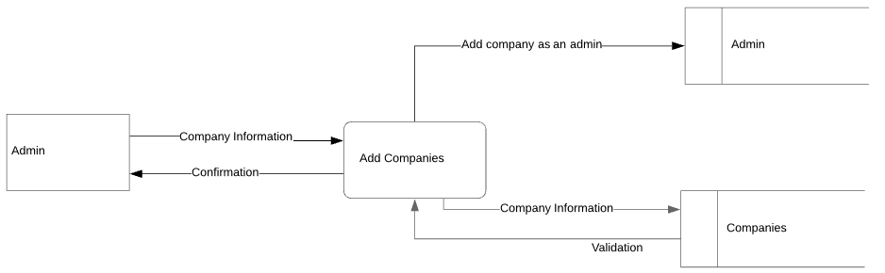

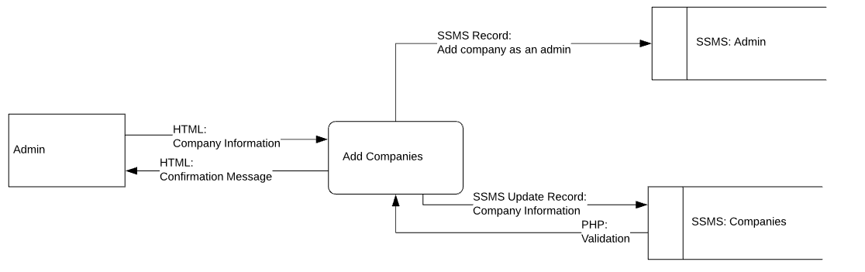

### Adds Jobs

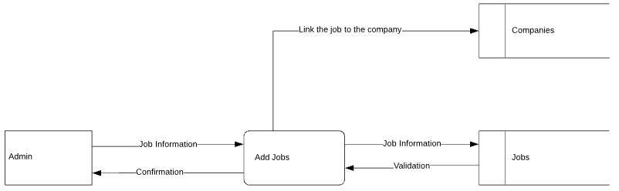

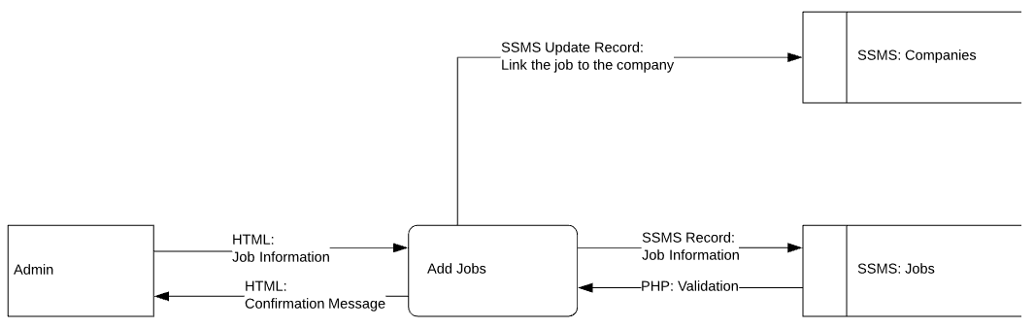

### Remove Jobs

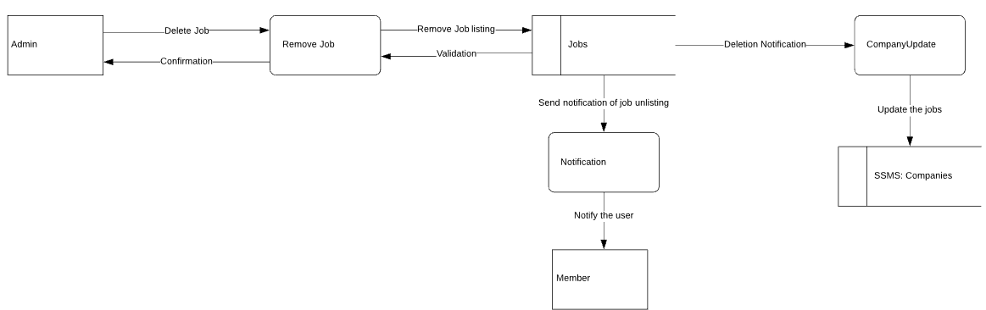

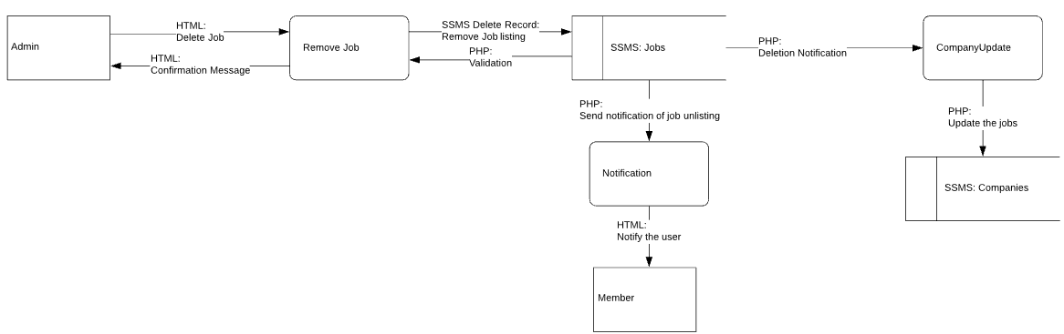

### View and Edit Members

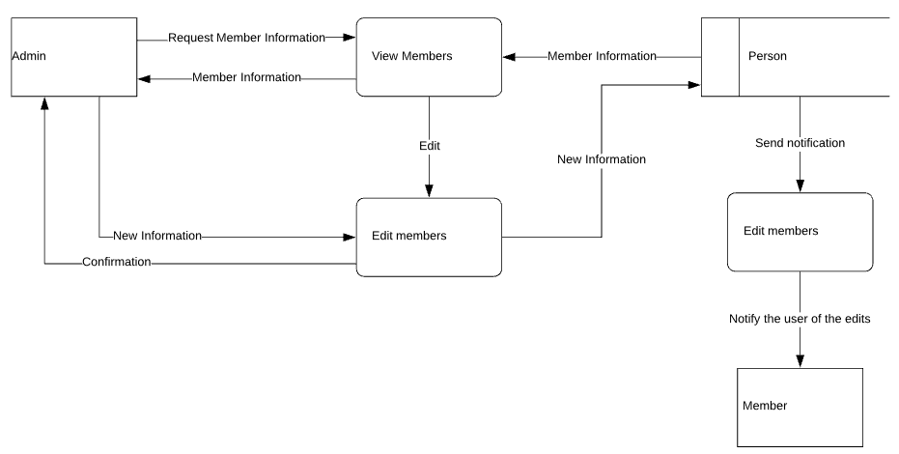

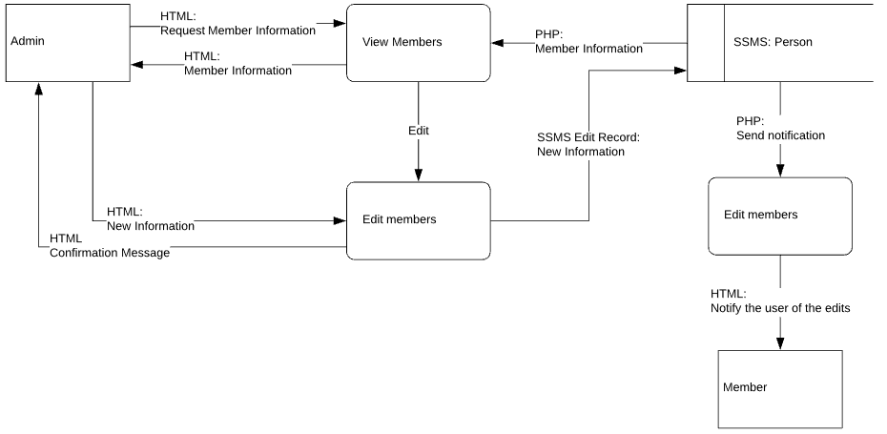

### Reply

